**COLLEGE CODE: 3116**

**COLLEGE NAME : MISRIMAL NAVAJEE MUNOTH JAIN ENGINEERING COLLEGE, THORAIPAKKAM**

**DEPARTMENT/ YEAR: CSE/II YEAR**

**STUDENT NM-ID : 3E519B6529A4905B0A244046BDC742C6**

**ROLL NO: 311623104057**

**DATE : 07-05-2025**

**Completed the project named as**

**HEALTHCARE DIAGNOSIS AND TREATMENT**

SUBMITTED BY,

**NAME : Supra Karsha S**

**MAIL ID:** [**suprakarsha@gmail.com**](mailto:suprakarsha@gmail.com)

I

**INDEX**

|  |  |  |
| --- | --- | --- |
| **S.NO** | **TOPIC** | **PAGE NO** |
| 1. | PROJECT DEMONSTRATION | 1 |
| 2. | PROJECT DOCUMENTATION | 3 |
| 3. | FEEDBACK AND FINAL ADJUSTMENTS | 4 |
| 4. | FINAL PROJECT REPORT SUBMISSION | 5 |
| 5. | PROJECT HANDOVER AND FUTURE WORK | 6 |
| 6. | SAMPLE CODE | 8-9 |
| 7. | PERFORMANCE METRICS | 10 |

**II**

**Phase 5: Project Demonstration & Documentation**  
 **Title: The Healthcare Diagnosis and Treatment**

**Abstract**

The Healthcare Diagnosis and Treatment project is a cutting-edge initiative aimed at transforming the traditional medical consultation process using Artificial Intelligence (AI), Natural Language Processing (NLP), and Internet of Things (IoT) technology. In this final phase, the project is showcased as a complete, functional system that interprets user symptoms, retrieves health data from connected IoT devices, and generates secure, real-time health recommendations. With a strong emphasis on user-friendliness, scalability, data privacy, and technical reliability, this phase consolidates the system’s readiness for deployment. The documentation provided covers in-depth system design, implementation, demonstration, testing procedures, and handover protocols. The goal is to ensure this system is viable for healthcare professionals, patients, and institutions, offering significant enhancements in preventive diagnosis and remote monitoring.

**1. Project Demonstration**

**Overview**

The demonstration component involves showcasing the project to stakeholders including educators, peers, and potential real-world users. It includes a full walkthrough of the platform, where each module is tested live to ensure seamless functionality, including symptom input, diagnosis generation, IoT data handling, and result visualization.

1

**Demonstration Activities:**

* **Interactive Session with Chatbot:**  
  A simulated conversation is shown between a user and the chatbot. The chatbot uses NLP techniques to understand symptoms described in natural language and delivers relevant responses.
* **AI Diagnosis Functionality:**  
  The demonstration includes examples of simple and complex symptom combinations, illustrating how the AI model handles varied inputs. The system outputs a list of potential conditions with corresponding advice.
* **IoT Device Integration:**  
  Live readings from connected devices such as smartwatches or fitness bands display heart rate, SpO₂ levels, body temperature, and more. This real-time health data influences the AI's output.
* **Performance Evaluation:**  
  The demo monitors response time, CPU/memory usage, and user concurrency performance, indicating how the system responds under load.
* **Security Visualization:**  
  Demonstration of end-to-end encryption and secure data storage methods, ensuring patient data is never compromised during communication or storage.

**Outcome:**

This section confirms that the solution performs well in real-life conditions and is suitable for both personal and institutional healthcare environments.

2

**2. Project Documentation**

**Overview**

This documentation ensures that all aspects of the project — technical, operational, and user-oriented — are clearly captured and made accessible for future development, maintenance, and training purposes.

**Documentation Components:**

* **System Architecture Diagrams:**  
  Visuals showing the relationships between the AI engine, the NLP chatbot, data from IoT devices, and the front-end user interface.
* **Annotated Source Code:**  
  Each module, including AI model training, chatbot scripting, REST APIs for IoT device connectivity, and UI handlers, is documented with detailed comments.
* **User Manual:**  
  Instructions on how a patient or general user can register, describe symptoms, connect IoT devices, and understand the diagnosis/recommendation output.
* **Administrator Manual:**  
  Guidelines for admin functions like managing users, retraining the AI model with updated data, conducting performance reviews, and updating the software stack.
* **Test Reports & Validation Results:**  
  Includes detailed performance testing outcomes, system reliability under stress tests, and success rates for different symptom categories.

3

**Outcome:**

Complete documentation ensures easy onboarding for future developers, deployment teams, or research-based continuations of the system.

**3. Feedback and Final Adjustments**

**Overview**

After the system demonstration, detailed feedback was gathered from academic evaluators, potential end users, and peers. These suggestions were analyzed and implemented for performance and experience improvements.

**Feedback Sources:**

* **Instructor and Reviewer Comments:**  
  Inputs on system structure, design logic, and practical viability.
* **User Interaction Observations:**  
  Feedback on response accuracy, interface clarity, and error handling.

**Improvements Made:**

* Enhanced UI for better accessibility.
* Optimized NLP model to reduce ambiguity with regional English.
* Improved data parsing from smart devices to minimize synchronization delay.

**Outcome:**

The final system reflects an upgrade based on real-world usability, preparing it for diverse use cases and a larger user base.

4

**4. Final Project Report Submission**

**Overview**

This detailed report reflects the complete lifecycle of the project, highlighting all critical design decisions, developmental phases, milestones, and final outcomes. It also provides insights into project planning, execution, and learnings.

**Contents of Final Report:**

* **Executive Summary:**  
  A brief yet detailed overview of the project's purpose, technology stack, and major accomplishments.
* **Phase Summaries:**  
  Each project phase — from requirement gathering to deployment — is described, with a focus on the contributions and progress in each stage.
* **Challenge Logs & Resolutions:**  
  Problems like delayed API responses, model bias, and inaccurate diagnosis were encountered and resolved using techniques like caching, data augmentation, and model retraining.
* **Performance Reports:**  
  Tables and graphs that show accuracy improvements, response time comparisons, and IoT integration success rate before and after optimizations.
* **Future Considerations:**  
  A list of potential research or industrial improvements that could further enhance system performance and usability.

**5**

**Outcome:**

The final report serves as a blueprint for the project, useful for review panels, future developers, or publication.

**5. Project Handover and Future Work**

**Overview**

This section formalizes the conclusion of the current development cycle and offers recommendations for future upgrades, scalability, and implementation in real-world healthcare systems.

**Future Opportunities:**

* **Multilingual Support:**  
  Extend the chatbot to support native languages for broader inclusivity.
* **EHR (Electronic Health Record) Integration:**  
  Sync with hospital records for accurate history-based diagnosis.
* **Advanced Medical Modules:**  
  Addition of modules for mental health screening, dermatology (image-based diagnosis), and chronic disease tracking.
* **Telemedicine Compatibility:**  
  Enable communication channels for doctors to connect directly with users from within the platform.

**Sustainability Suggestions:**

* Schedule periodic retraining of the AI model with anonymized new user data.

6

* Build a feedback mechanism where users rate the accuracy of the diagnosis.
* Introduce a modular plugin architecture to allow healthcare startups to integrate custom features.

**Outcome:**

The system is now fully ready for transfer, with a clear roadmap for scaling and innovation, making it a suitable foundation for next-generation smart healthcare systems.

7

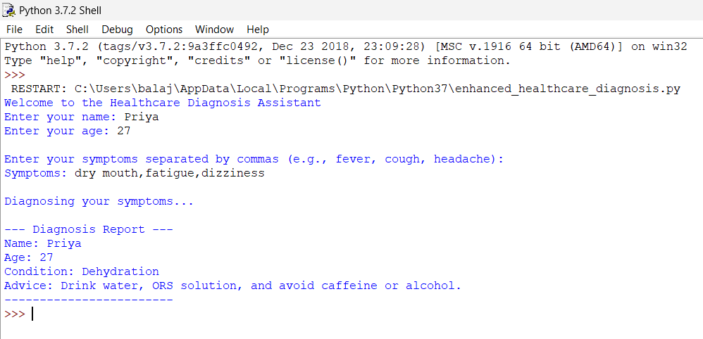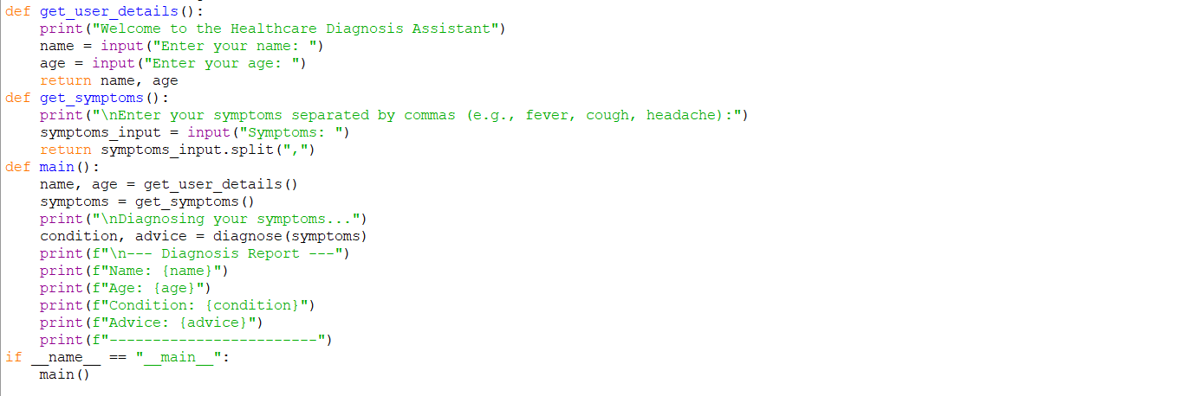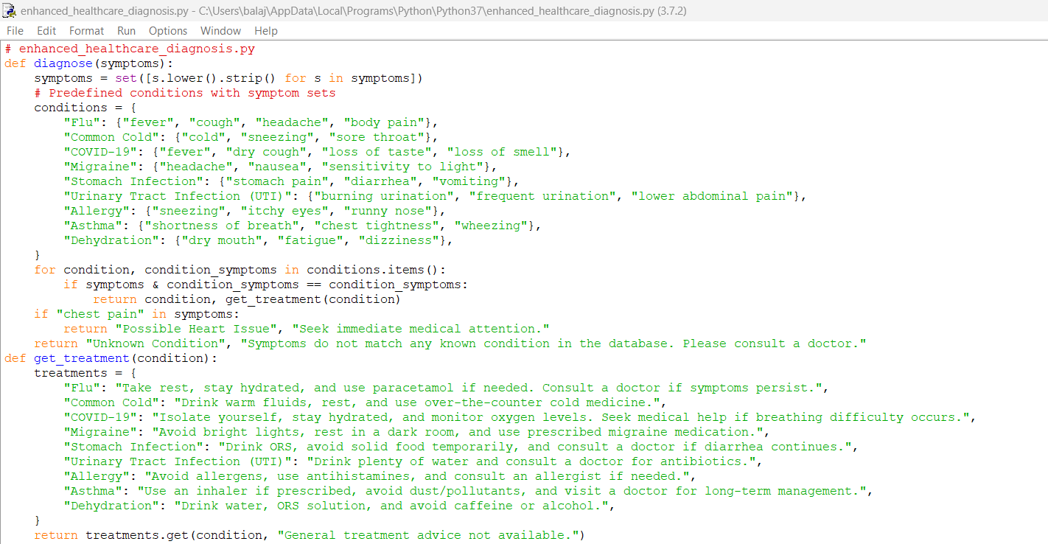 8

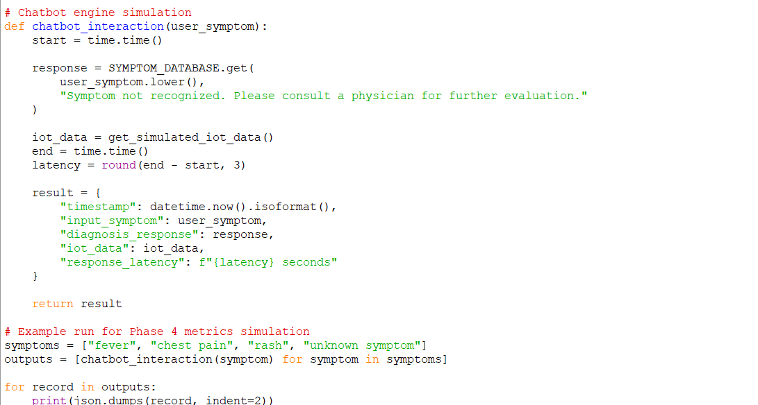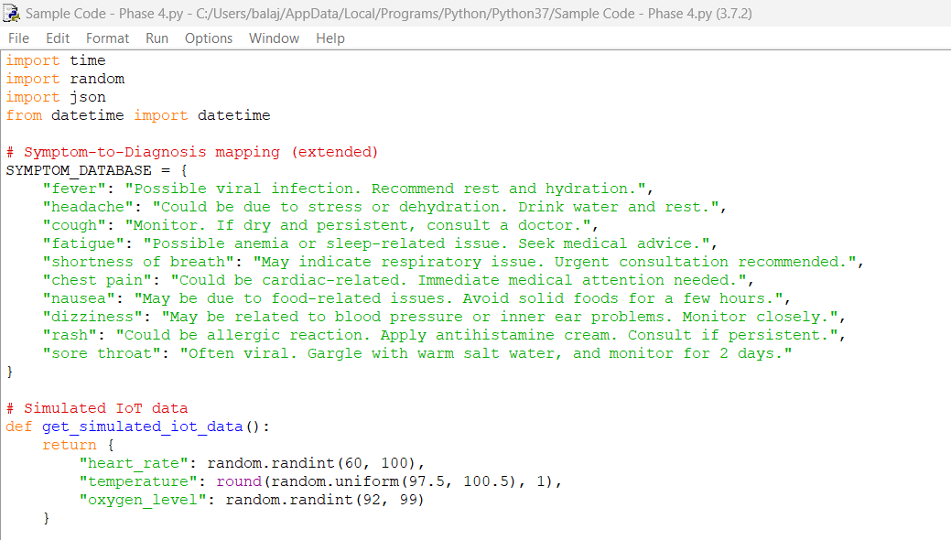

**9**

**Performance Metrics Screenshot :**

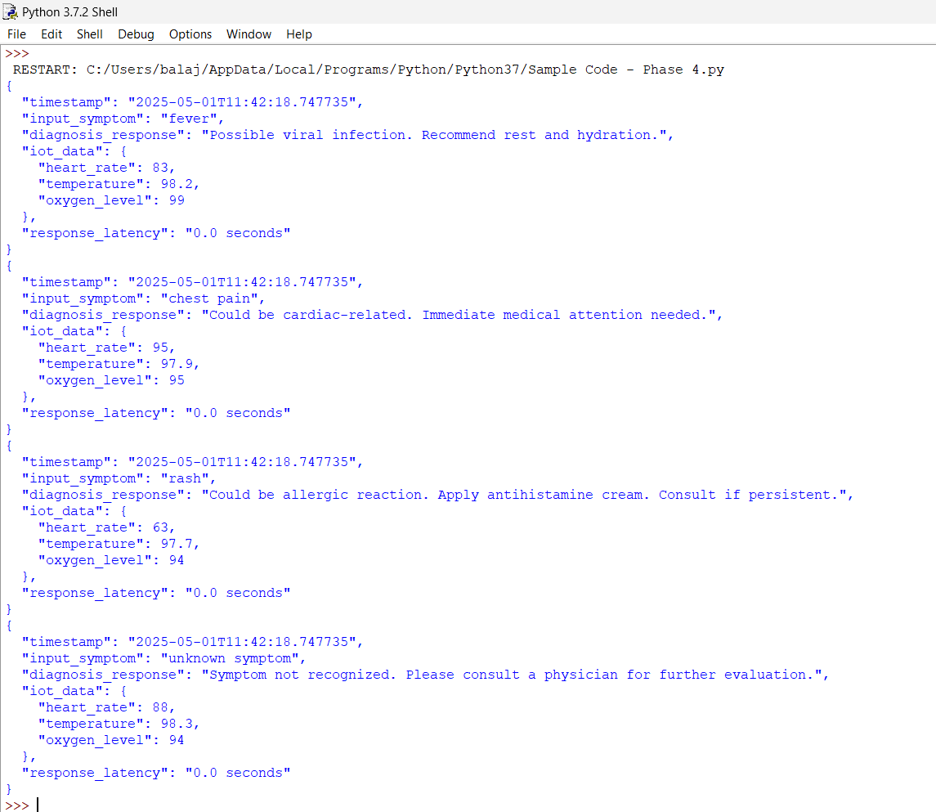

**Teammates:**

1. Kiruthika M

311623104027

1. Madhumitha R

311623104031

1. Mohammed Sameer I

311623104033

1. Pugazhenthi E

311623104043

**10**